**DAILY ONLINE ACTIVITIES SUMMARY**

|  |  |  |  |  |  |  |  |  |
| --- | --- | --- | --- | --- | --- | --- | --- | --- |
| **Date:** | **22/06/2020** | | | | | **Name:** | **NAIPUNYA VINOD NAIK** | |
| **Sem & Sec** | **IV SEM & A SECTION** | | | | | **USN:** | **4AL18CS050** | |
| **Online Test Summary** | | | | | | | | |
| **Subject** | | **NO INTERNALS CONDUCTED** | | | | | | |
| **Max. Marks** | | **-----------------** | | **Score** | | | **--------------------** | |
| **Certification Course Summary** | | | | | | | | |
| **Course** | **1)WEBINAR ON IOT**  **2)LEARN PYTHON FROM ZERO TO HERO**  **3) IP ADDRESSING FROM ZERO TO HERO** | | | | | | | |
| **Certificate Provider** | | | **1)AIET**  **2)UDEMY**  **3)UDEMY** | | **Duration** | | | * 1. **HR**   **2) 30 MIN**  **3)2.5 HRS** |
| **Coding Challenges** | | | | | | | | |
| **Problem Statement:** [Write a Java Program for Modular Exponentiation](https://github.com/orgs/alvas-education-foundation/teams/2nd-year/discussions/133).  Top of Form  Bottom of Form | | | | | | | | |
| **Status: EXECUTED** | | | | | | | | |
| **Uploaded the report in Github** | | | | | **YES** | | | |
| **If yes Repository name** | | | | | <https://github.com/naipunya-naik/lockdown-coding/blob/master/JAVA%20CODING/modular_22-06-2020.java>  Top of Form  Bottom of Form | | | |
| **Uploaded the report in slack** | | | | | **YES** | | | |

Online Test Details: (Attach the snapshot and briefly write the report for the same).

NO INTERNALS CONDUCTED

Certification Course Details: (Attach the snapshot and briefly write the report for the same)

1. TODAY I ATTENDED A WEBINAR ON IOT-OPPURTUNITIES AND CHALLENGES. 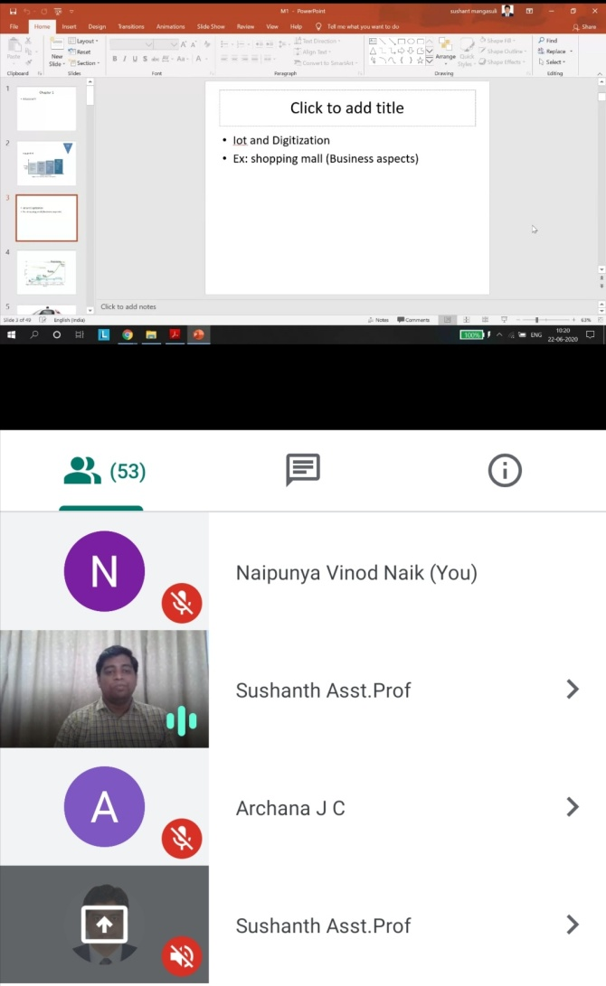

THINGS LEARNT FROM THIS WEBINAR TODAY:-

* WHAT IS IOT?
* IMPORTANCE OF IOT
* APPLICATIONS OF IOT
* IOT SENSORS AND ACTUATORS

1. CERTIFICATION COURSE NAME:- LEARN PYTHON FROM ZERO TO HERO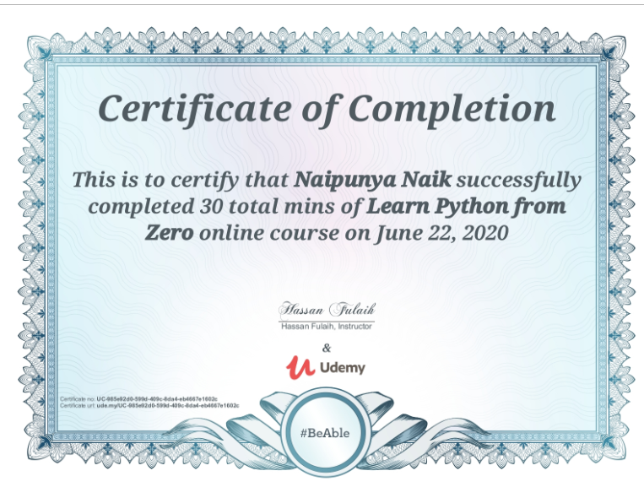

TOPICS LEARNT ON 22 JUNE 2020:-

* INTRODUCTION
* OUTPUTS
* VARIABLES
* COMMENTS
* TYPE CASTING
* AGE CALCULATOR
* LOGICAL OPERATOR
* MATHS OPERATOR
* ORDER OF OPERATION
* IF STATEMENTS

1. CERTIFICATION COURSE NAME:- IP ADDRESSING FROM ZERO TO HERO

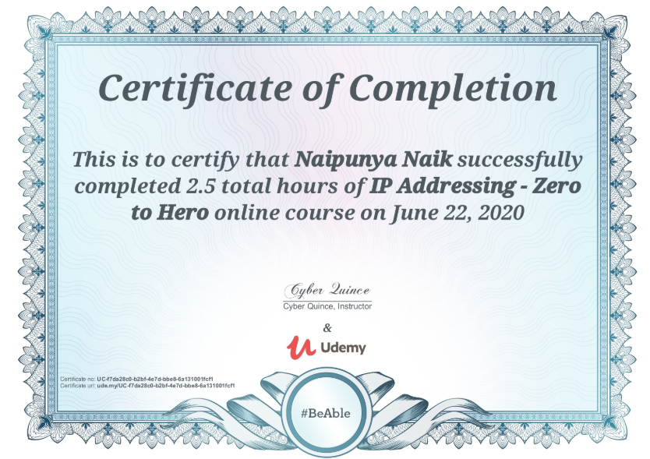

TOPICS LEARNT ON 22 JUNE 2020:-

* IPV4
* IP SUBNETTING
* FLSM SUBNETTING
* VLSM SUBNETTING
* SUMMARIZATION (SUMMARY IP)

Coding Challenges Details: (Attach the snapshot and briefly write the report for the same)

PROBLEM STATEMENT:- [Write a Java Program for Modular Exponentiation](https://github.com/orgs/alvas-education-foundation/teams/2nd-year/discussions/133)

Top of Form

Bottom of Form

|  |
| --- |
| Given three numbers x, y and p, compute (xy) % p. Input: x = 2, y = 3, p = 5 Output: 3 Explanation: 2^3 % 5 = 8 % 5 = 3.  Input: x = 2, y = 5, p = 13 Output: 6 Explanation: 2^5 % 13 = 32 % 13 = 6. |

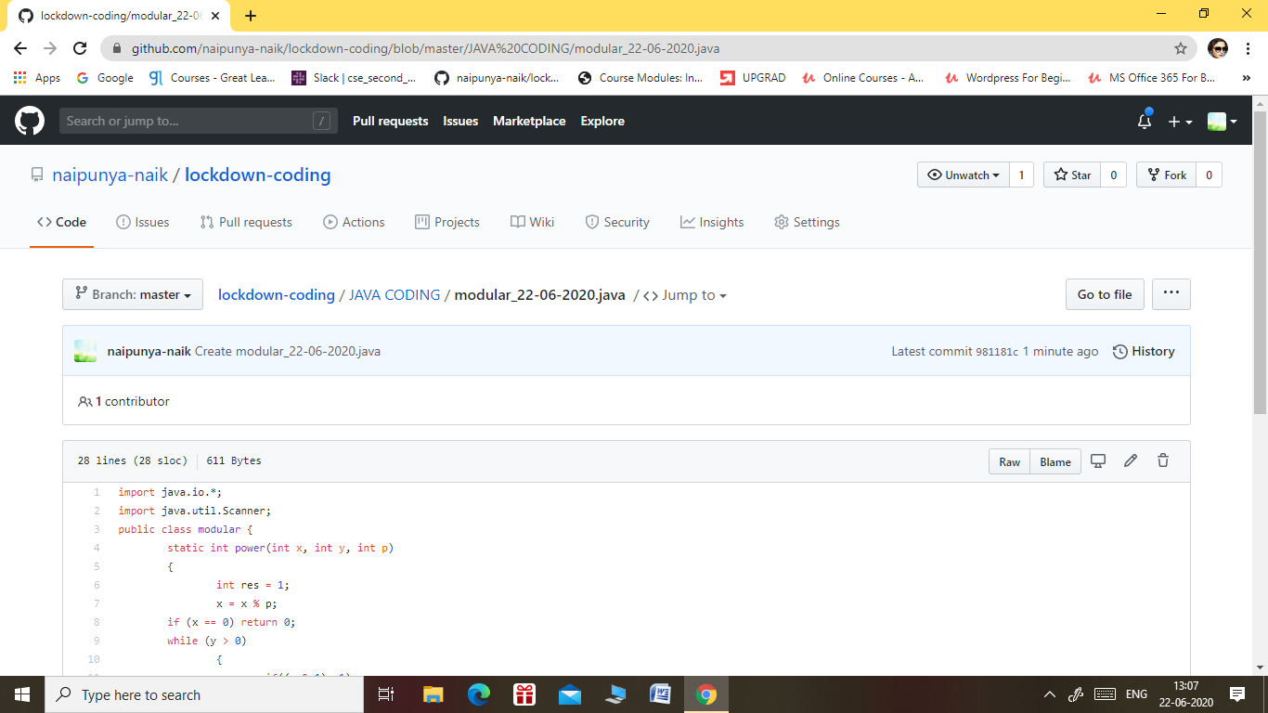

GITHUB REPOSITORY LINK:-

<https://github.com/naipunya-naik/lockdown-coding/blob/master/JAVA%20CODING/modular_22-06-2020.java>